PREPTALK

Yashi Ratnakar - 9921103011 Rahi Agarwal - 9921103145 Armaan Sharma - 9921103165

Group Number - 38

Name of supervisor – **Dr. Shruti Gupta**

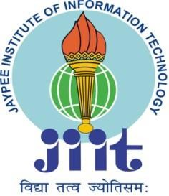

# November 2024

Submitted in partial fulfillment of the Degree of Bachelor of Technology in

Computer Science and Engineering

## Department of Computer Science & Engineering and Information Technology Jaypee Institute of Information Technology, Noida

**TABLE OF CONTENTS**

Chapter No. Topics Page No.

Chapter-1 **Introduction**

|  |  |  |
| --- | --- | --- |
|  | 1.1 General Introduction | 1 |
| 1.2 Problem Statement | 2 |
| 1.3 Significance/Novelty of the problem | 3 |
| 1.4 Empirical Study | 4 |
| 1.5 Brief Description of the Solution Approach | 5 |
| 1.6 Comparison of existing approaches to the problem framed | 6 |
| Chapter-2 | **Literature Survey** |  |
|  | 2.1 Summary of papers studied | 7 |
|  | 2.2 Integrated summary of the literature studied | 9 |
| Chapter-3 | **Requirement Analysis and Solution Approach** |  |
|  | 3.1 Solution Approach | 10 |
|  | 3.2 Solution Approach Overview | 22 |
| Chapter-4 | **Modeling and Implementation Details** | 23 |
|  | 4.1 Implementation details and issues | 24 |

# Chapter 1: Introduction

## General Introduction

The proposed web application focuses on preparing students, fresh graduates, and job seekers for interviews by integrating several key features tailored to their specific needs. By combining real-life interview experiences, up-to-date job market trends, and expert mentorship opportunities, this platform addresses common challenges faced during interview preparation.

## Core Features:

The application offers several modules:

1. **Interview Experience Sharing:** This feature provides users with firsthand accounts of interview processes across different companies, highlighting frequently asked questions, strategies, and success stories.
2. **Job Market News and Openings:** Utilizing APIs like Google News, this module delivers real-time updates on trending industry news and job openings, helping users stay informed about market trends and opportunities.
3. **Mentor Chatroom**: This module connects users with industry-leading professionals and LinkedIn mentors for personalized guidance and support, enabling them to ask questions and gain unique insights from experienced experts.
4. **AI-Powered Chatbot:** The AI chatbot serves as a user assistant, providing quick answers to questions, explaining platform features, and even conducting simulated interview sessions for practice.

## Impact on User Experience

By leveraging artificial intelligence, natural language processing (NLP), and real- time interaction capabilities, the web application creates an adaptive and responsive environment. It transforms traditional interview preparation into a more accessible, interactive, and personalized journey, empowering users to build confidence, gain relevant insights, and enhance their preparedness for job interviews.

## Problem Statement

To effectively address the challenges faced by job seekers, it is crucial to identify the key gaps in traditional interview preparation methods. Below are the primary issues that hinder candidates from excelling in their job interviews:

## Disconnection Between Education and Employment

A common challenge for many job seekers is bridging the gap between theoretical knowledge acquired through education and the practical requirements of the job market. This disconnect often results in individuals entering job interviews unprepared for industry-specific questions and lacking the professional skills required by employers.

## Lack of Personalized Interview Preparation Resources

Fresh graduates and professionals often struggle with limited or generic preparation tools, making it difficult to stand out during job interviews. Traditional resources, such as books or online articles, often fail to offer tailored guidance that aligns with individual career goals and industry expectations. This lack of personalization makes it harder for candidates to build the necessary confidence and skills for interviews.

## Absence of Real-Time Mentorship and Interaction

Access to industry experts and mentors is crucial for building practical insights and understanding real-world expectations. However, existing platforms do not always provide opportunities for personalized mentorship or live interactions with professionals, depriving job seekers of valuable networking and direct guidance.

## Limited Access to Relevant Information

Keeping up with job market trends, company-specific interview formats, and the latest industry requirements is a significant challenge. The absence of centralized resources for current job openings, real-life interview experiences, and practical insights further hampers the preparation process for many individuals. This platform aims to address these challenges by integrating AI-driven modules, personalized mentorship, and real-time information aggregation to empower job seekers with the tools they need to succeed.

## Significance/Novelty of the Problem

The project blends traditional interview prep with AI-driven insights and real-time mentorship, offering personalized, practical guidance. It bridges the gap between theory and industry-specific skills.

## Unique Integration of Traditional and AI Approaches

1. Combines conventional resources such as interview guides and practice tests with cutting-edge AI technologies.
2. Utilizes Natural Language Processing (NLP) to extract meaningful insights from user-contributed interview feedback and job descriptions, offering personalized guidance tailored to individual career paths.

## 1.3.2 Real-Time Mentor Interaction for Practical Insights

1. Provides direct access to industry professionals for personalized, real-world advice.
2. Bridges the gap between theoretical knowledge and industry-specific skills, offering users the chance to receive hands-on guidance and insider tips.

## 1.3.3 AI Chatbot for Enhanced Engagement and Learning

1. Serves as an interactive assistant, offering immediate responses to user queries, simulating mock interviews, and delivering context-aware guidance.
2. Enhances user preparation by enabling practice and personalized responses, tailored to their career goals and challenges.

## 1.3.4 Centralized Solution for Interview Challenges

1. Unlike traditional, fragmented resources, this platform provides a holistic approach by integrating mentorship, AI-driven insights, and curated user content.
2. Addresses common problems such as a lack of industry-specific preparation, the need for personalized mentorship, and the gap between education and employment.

## Empirical Study

The empirical study identified key user needs such as personalized guidance and job market updates through focus groups and tool evaluations. These insights led to the development of an AI-driven platform offering tailored career preparation with real-time updates and mentor interactions.

## Field Surveys and User Needs Assessment

1. Conducted focus groups with students, fresh graduates, and job seekers to understand their primary challenges in interview preparation.
2. Identified key needs such as personalized guidance, reliable job market updates, and access to experienced mentors.

## 1.4.2 Tool Evaluation for Enhanced Functionality

1. Google News API was evaluated for fetching real-time job market trends and relevant industry updates.
2. NLP models were considered for sentiment analysis and extracting meaningful feedback from user-contributed interview experiences.

## 1.4.3 Data-Driven, User-Centric Development

1. Combined insights from field studies and technical evaluations to create a solution that precisely addresses user needs.
2. Integrated tools ensure curated content delivery, timely job market updates, and actionable user feedback, all within a single platform.

## 1.4.4 Tailored Solutions through Advanced Technologies

1. Implemented AI-driven tools to deliver content based on individual user profiles, offering personalized insights and mentorship.
2. Ensures a seamless blend of real-time updates, mentor interactions, and data-driven guidance, bridging the gap between conventional resources and the latest in AI-driven career preparation.

## Brief Description of the Solution Approach

To address the challenges outlined in the problem statement, a comprehensive and innovative approach is required that combines technology with personalized resources. The proposed solution integrates AI-driven tools, real-time insights, and mentorship opportunities to bridge the gap between education and employment effectively.

## 1.5.1 Utilization of AI and NLP

## The solution leverages cutting-edge artificial intelligence (AI) and natural languag processing (NLP) to extract, analyze, and present valuable insights from diverse data sources. This includes job market trends, company-specific interview experiences, and curated job listings. By incorporating advanced analytics, the application provides precise and relevant information tailored to individual user profiles, ensuring that they receive actionable insights aligned with their career goals.

## 1.5.2 Interview Experience Module

This feature collects and organizes real-world interview experiences contributed by users. By categorizing content by company, job role, and type of questions asked, the module offers targeted preparation materials. Users can access detailed breakdowns of interview formats, sample questions, and strategies that have proven successful for others.

## 1.5.3 News & Job Market Insights

Powered by APIs like Google News, this module aggregates real-time updates on market trends, emerging industry demands, and job openings. Users can stay informed about critical developments and changes in the job market, making them better prepared for interviews and job opportunities.

## 1.5.4 Mentor Chatroom

This component connects users with top professionals, including LinkedIn industry leaders, for personalized advice. The real-time chat feature allows for questions, feedback, and career guidance, creating a unique mentorship opportunity that is often missing in traditional career-prep tools.

## 1.5.5 AI Chatbot

The chatbot acts as a virtual assistant, helping users navigate the platform, understand its features, and simulate mock interviews. Equipped with NLP capabilities, it responds intelligently to user queries, offers feedback, and creates personalized interactions that enhance overall learning and preparation.

## Comparison of Existing Approaches to the Problem

Traditional job preparation platforms fall short in providing personalized guidance and real-time industry insights. Our solution overcomes these gaps as follows:

## 1.6.1 Limited Capabilities of Generic Job Boards

Existing job boards primarily focus on listing job openings without providing tailored career guidance or mentorship. They often lack interactive elements, making them inadequate for comprehensive preparation. Users may find job openings but miss out on critical aspects such as interview techniques and personalized feedback. Moreover, these platforms typically do not offer real-time insights or direct access to industry experts, limiting their overall utility.

## 1.6.2 Absence of Personalized Mentorship

Most current solutions fail to offer personalized, mentor-driven guidance. Generic platforms do not include features like one-on-one mentorship or real-time interaction with experienced professionals. This gap leaves many job seekers with limited understanding of industry-specific expectations and little direct support in navigating complex interview processes.

## 1.6.3 AI-Driven Customization and Real-Time Interaction

In contrast, our proposed solution focuses on personalization through AI-driven analytics and real-time interactions. By leveraging NLP models, the system extracts valuable insights from diverse data sources and presents them in an intuitive, user-specific format. This tailored approach allows users to access information that directly matches their goals, background, and aspirations.

## 1.6.4 Enhanced Interview Preparation Modules

Unlike existing solutions, our platform includes an interview experience module that offers detailed and categorized content based on company-specific interviews. The curated news and job market insights provide a continuous stream of relevant updates, ensuring that users are always informed. This comprehensive preparation strategy enhances the user's ability to perform well during interviews.

## 1.6.5 Mentor Interaction and AI Chatbot Support

Personalized mentorship via the chatroom and AI chatbot interactions further set the solution apart. Users benefit from real-time, guided support, gaining practical insights, feedback, and industry knowledge that other platforms do not offer. This unique blend of mentorship and AI-driven content ensures a more effective preparation experience.

# Chapter 2: Literature Survey

The literature highlights AI's ability to personalize career guidance by aligning user profiles with industry needs. NLP improves interview prep by extracting insights from job descriptions and feedback. AI chatbots offer mock interviews, while mentorship platforms combine human advice with AI-driven insights. Despite challenges like data privacy and bias, this integration provides a transformative approach to career preparation.

## Summary of Papers Studied

This section summarizes research on AI in career guidance, NLP for interview prep, AI chatbots, and mentorship platforms. AI offers personalized, scalable career counseling, while NLP enhances interview prep by extracting insights from data. AI chatbots simulate real-life scenarios, providing tailored feedback, and mentorship platforms combine human expertise with AI to improve career success.

## 2.1.1 AI and Career Guidance

**Reference: IAFOR Publications. *Artificial Intelligence in Career Guidance and Employment: Bridging the Gap*.[[1]](https://iafor.org/archives/journals/iafor-journal-of-education/10.22492.ije.9.4.03.pdf)**

Research on the integration of artificial intelligence for career guidance and interview preparation highlights its transformative potential. AI-driven platforms can offer personalized, scalable, and effective career counseling services. A study by IAFOR Publications emphasizes that AI-powered tools address the gap between higher education outcomes and employment needs by matching user profiles with industry demands, though ethical concerns like data privacy must be handled with care. This approach empowers job seekers to identify their strengths and align their skills with market opportunities, enhancing overall employability.

## 2.1.2 NLP in Interview Preparation

**Reference: ERIC. *Natural Language Processing for Interview Preparation: Techniques for Analysis and Feedback*[.[](https://joingenius.com/interview-questions/natural-language-processing-engineer/)2]**

Natural Language Processing has proven effective in enhancing interview preparation by organizing and analyzing vast amounts of unstructured data. An ERIC study discusses the use of Named Entity Recognition, sentiment analysis, and text summarization to extract key information from job descriptions, interview feedback, and user-contributed experiences. This allows for the identification of relevant themes, patterns in company-specific questions, and detailed feedback on user performance, thus providing a structured framework for preparation.

## 2.1.3 Interactive AI Chatbots

**Reference: Author(s). *AI Chatbots in Career Development: Enhancing Interview Preparation.*[3]**

Several research papers have explored the use of AI chatbots in the career development space. These systems employ advanced NLP models to simulate real- life scenarios, such as mock interviews, and provide instant feedback. **[Figure 2.1]** shows the workflow of the AI bot, detailing its interaction with the user inputs and outputs through various NLP and sentiment analysis techniques. Leveraging pre- trained language models, chatbots can understand and respond to user queries contextually, making them valuable tools for preparing job candidates through realistic simulations and tailored advice.

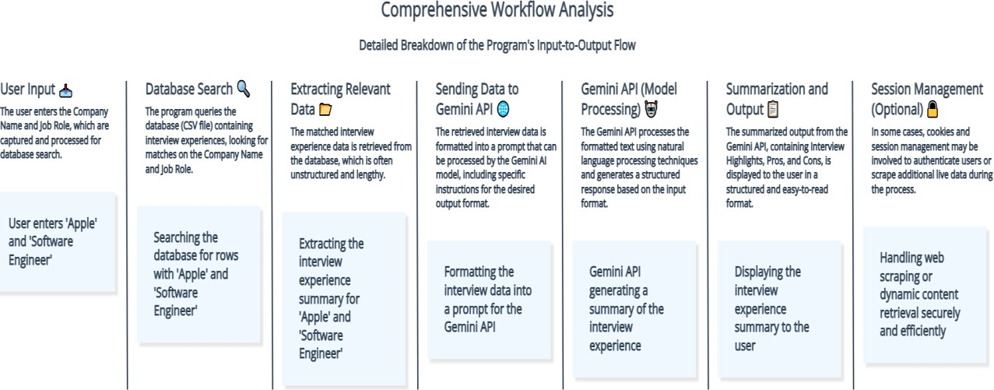

**Figure 2.1 AI Bot Workflow**

## 2.1.4 Mentorship Platforms

**Reference: Author(s). *Mentorship Platforms: Integrating AI and Human Interaction for Career Success***.**[4]**

Real-time mentor interaction platforms have demonstrated the importance of personalized guidance in career success. Platforms that connect job seekers with experienced mentors help bridge the knowledge gap between education and employment, offering industry insights and practical advice. Research suggests that this human interaction, combined with AI-driven guidance, can significantly improve user preparedness and career success rates.

## Integrated Summary of the Literature

Traditional career guidance methods often face challenges such as limited scalability and a lack of personalization, which restrict their effectiveness in helping individuals make informed career decisions or prepare for interviews. Research emphasizes the transformative potential of AI and NLP technologies in overcoming these limitations by delivering tailored, data-driven solutions. AI-powered systems can aggregate and analyze data from various sources, offering personalized recommendations aligned with an individual's goals and market demands. NLP tools complement this by extracting key insights from unstructured data, such as interview feedback and job descriptions, summarizing long-form content, identifying trends, and enabling efficient preparation. Despite these advancements, the integration of AI in career guidance brings challenges related to data privacy, ethical concerns, and potential biases in AI models, which, if left unaddressed, could lead to less accurate or unfair recommendations. To mitigate these issues, combining AI-driven analytics with real-time mentorship provides a balanced approach, merging the efficiency of AI with the human touch of industry-specific guidance and experience-based insights. This hybrid model, offering 24/7 AI support alongside personalized mentorship, has the potential to revolutionize the career guidance and interview preparation landscape, meeting the diverse needs of job seekers more comprehensively

# Chapter 3: Requirement Analysis and Solution Approach

## 3.1 Solution Approach

The solution approach focuses on bridging the gap between theoretical knowledge and industry-specific skills by leveraging advanced technology and user-centric methodologies. By combining AI-driven tools, real-time data aggregation, and personalized mentorship, the proposed system offers a holistic framework for interview preparation. Below are the key elements of this approach

## 3.1.1 Identifying User Requirements

The proposed solution targets students, job seekers, and professionals who require comprehensive and personalized interview preparation resources. Extensive user surveys, focus groups, and competitor analyses were conducted to understand the needs of the target audience. Key insights revealed a demand for personalized mentorship, access to real-world interview experiences, relevant job market updates, and interactive tools like mock interviews. These requirements shaped the overall design and functionality of the web application. **Figure 3.1** shows the overall system workflow, depicting interactions between modules like the interview experience module, job market insights, mentor chatroom, and AI chatbot.

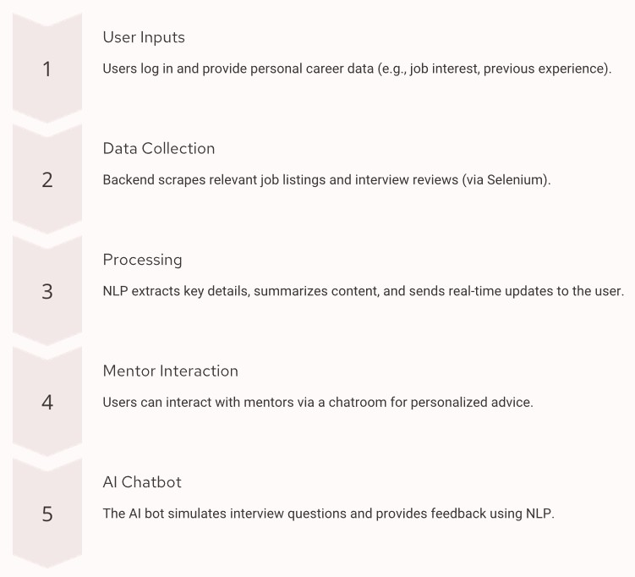

**Figure 3.1 System Workflow**

**Figure 3.2** shows the UML diagram of the system, outlining the structural design and relationships between various system components like the interview experience module, job market insights, mentor chatroom, and AI chatbot. **Figure 3.3** shows the sequence diagram, depicting the flow of interactions between users, system modules, and external APIs during the execution of a specific use case.

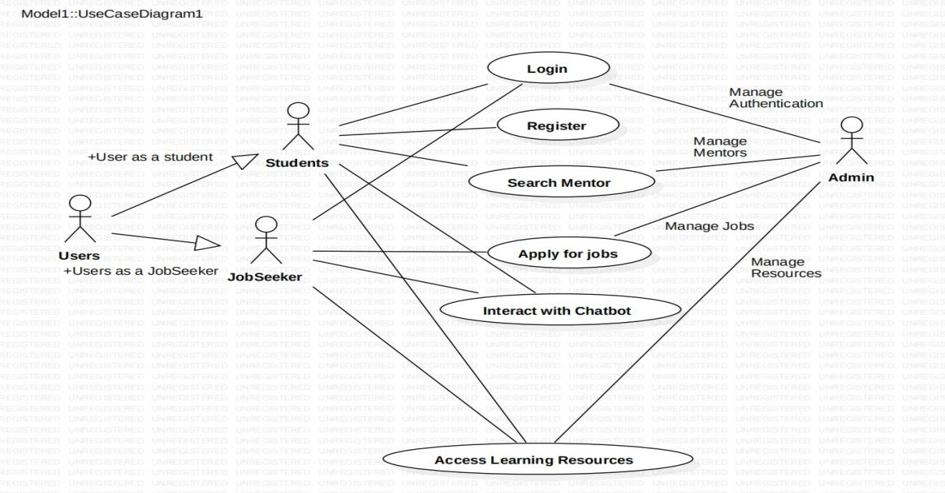

**Figure 3.2 UML Diagram**

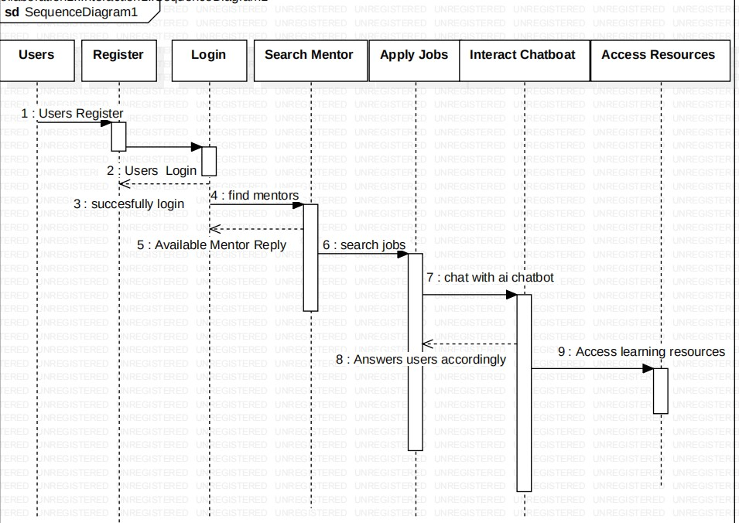

**Figure 3.3 Sequence Diagram**

# Functional Requirements:

## User Registration and Profile Management

Users need to create and manage their profiles, specifying their career interests, past experience, and goals. This enables personalized recommendations and tailored content delivery. **Figure 3.4** shows the user login interface, illustrating the layout and fields required for secure user authentication. **Figure 3.5** shows the signup interface where users create profiles by inputting personal and professional details.

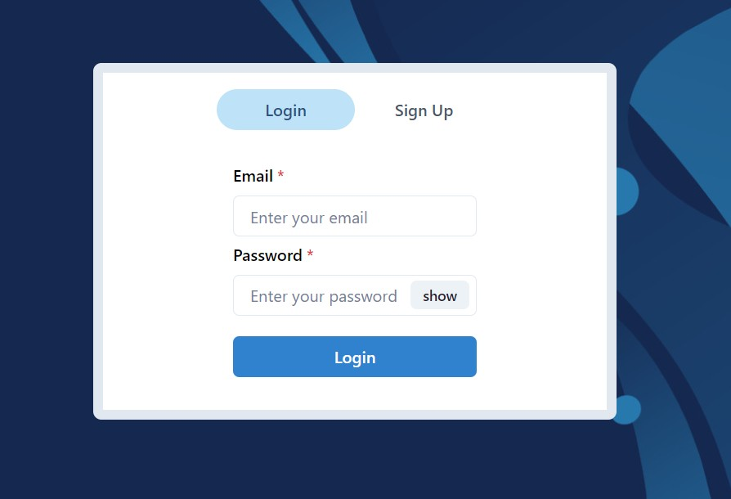

**Figure 3.4 User Login**

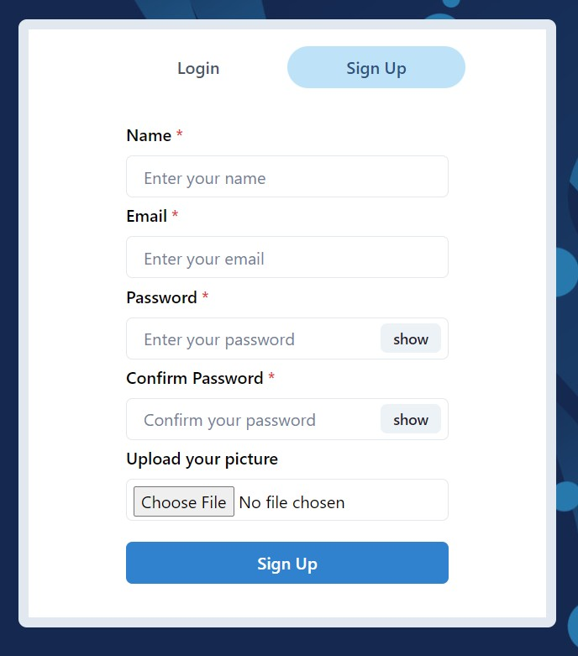

**Figure 3.5 User SignUp**

## Interview Experience Module

Users should be able to access and contribute real-life interview experiences categorized by company and job role. The module will include features for searching, filtering, and bookmarking relevant content for future reference. **Figure 3.6** shows the libraries and tools used for implementing the interview experience module. **Figure 3.7** shows the implementation details of web scraping, including the libraries and techniques used for gathering interview data. **Figure 3.8** shows the output of the web scraping process, presenting a sample of the collected data

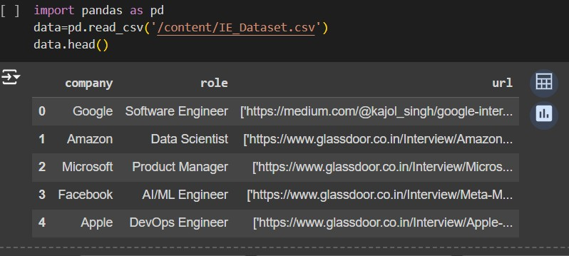

**Figure 3.6 Libraries**

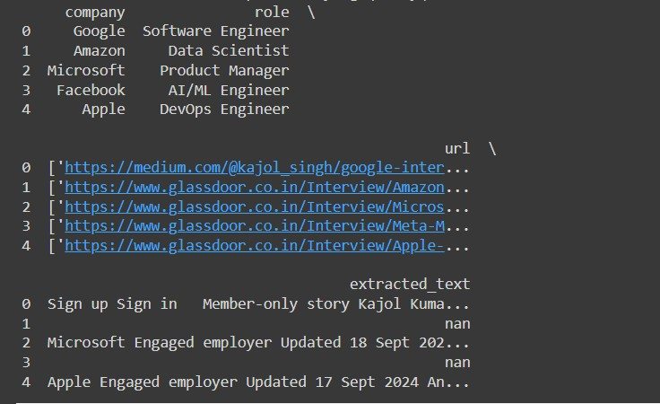

**Figure 3.7 Webscraping**

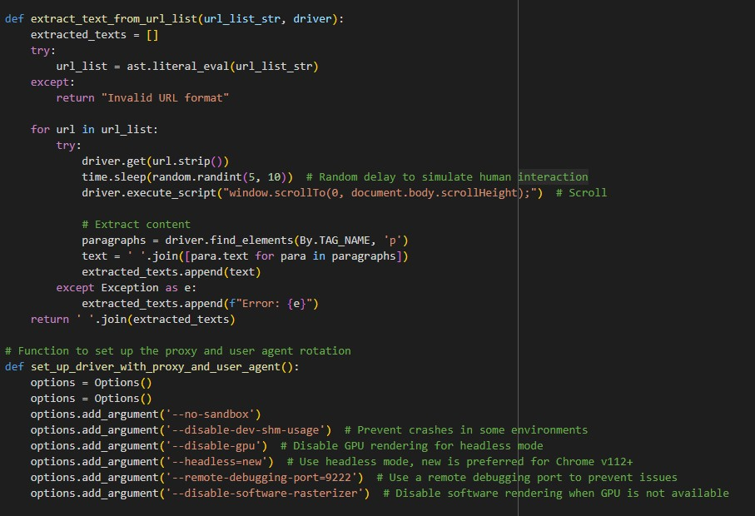

**Figure 3.8 Webscraping**

## Job Market and News Insights

This module aggregates market trends, job openings, and news articles using APIs like Google News. Personalized news feeds based on user preferences are delivered to keep users informed of industry developments and career opportunities. **Figure 3.9** shows the user interface for accessing news and job market insights, highlighting key elements like personalized news feeds.

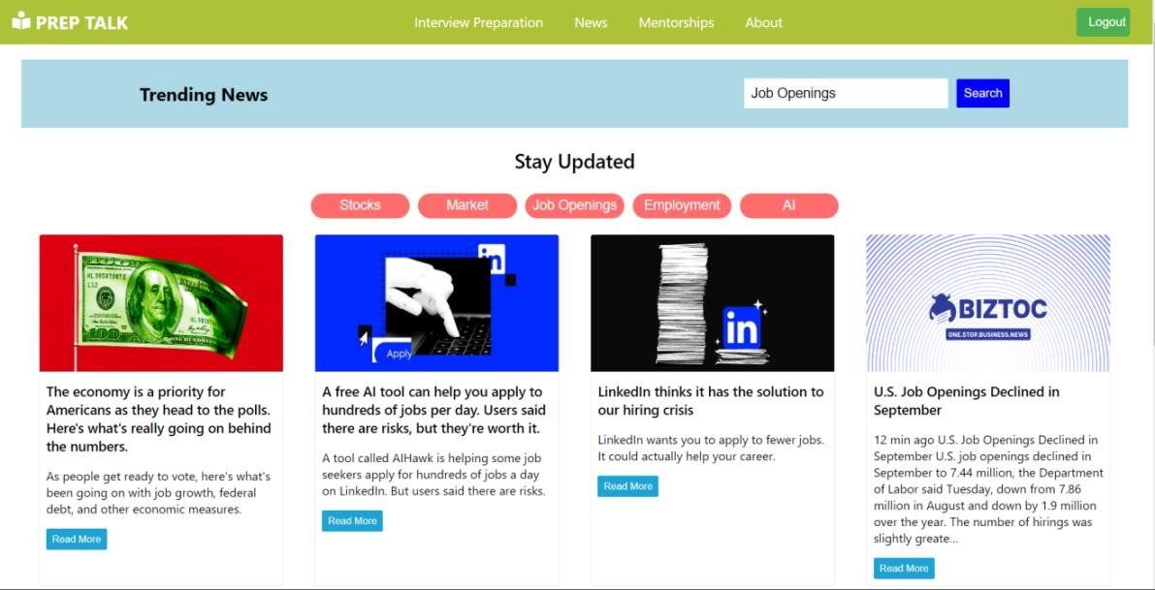

**Figure 3.9 News User Interface**

**Figure 3.10** shows the functionality of the "Read More" button, which allows users to access detailed articles related to job trends. **Figure 3.11** shows the expanded view of an article displayed after clicking the "Read More" button. **Figure 3.12** shows the code snippet used for integrating the Google News API to fetch real-time job market insights.



**Figure 3.10 Read More Button**

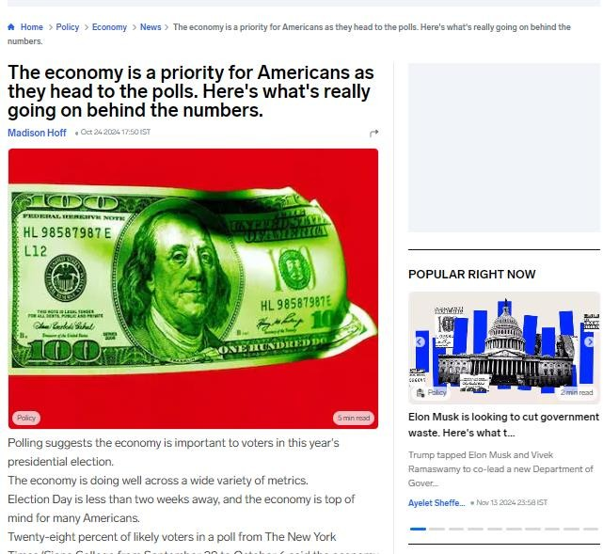

**Figure 3.11 After Clicking the Read More**

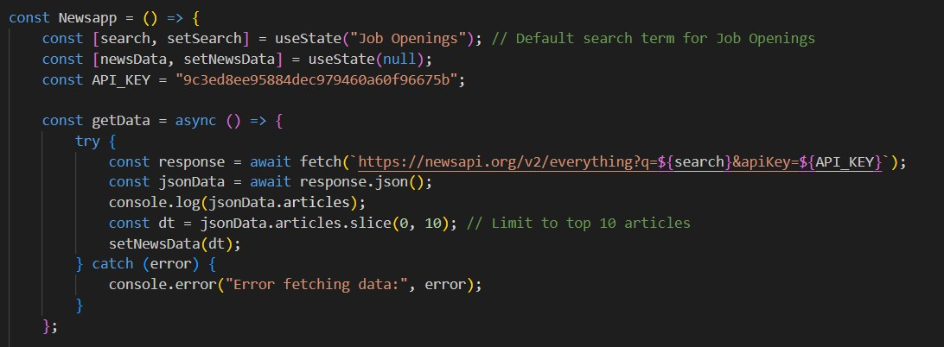

**Figure 3.12 API Intergration Code**

## Mentor Chatroom

A real-time communication module connects users with industry professionals for personalized mentorship. The module requires secure user authentication and messaging capabilities to facilitate interactions. **Figure 3.13** shows the layout of the mentorship chatroom interface, where users can communicate with industry professionals. **Figure 3.14** shows the profile layout of mentors, providing details like their expertise, experience, and availability for chats.

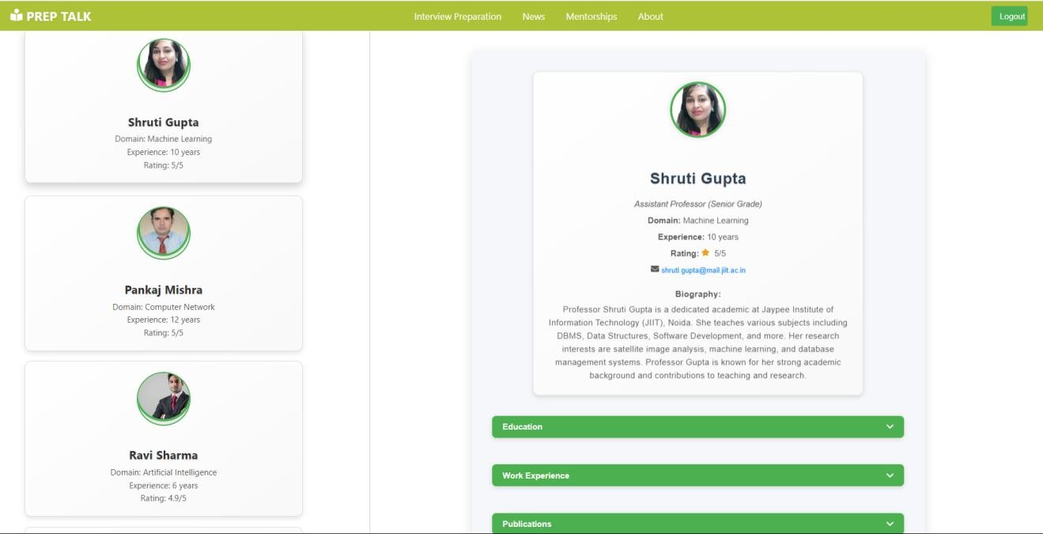

**Figure 3.13 Mentorship User Interface**

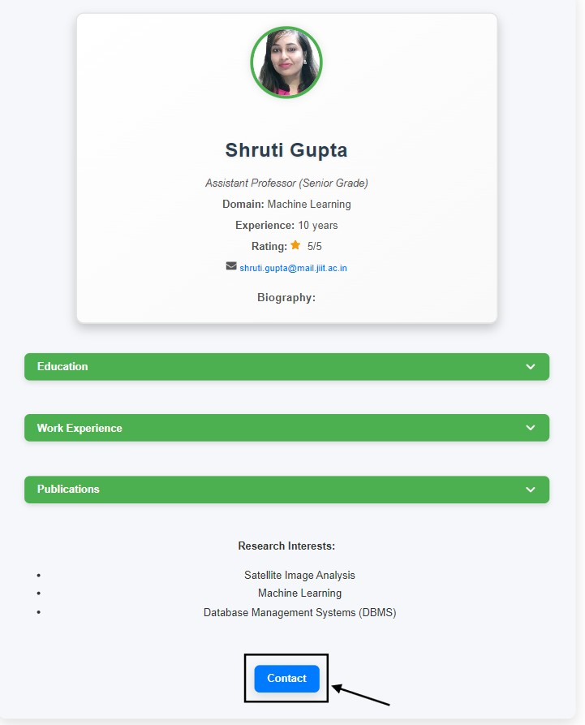

**Figure 3.14 Mentor Profile**

**Figure 3.15** shows the real-time chat interface between a user and a mentor.

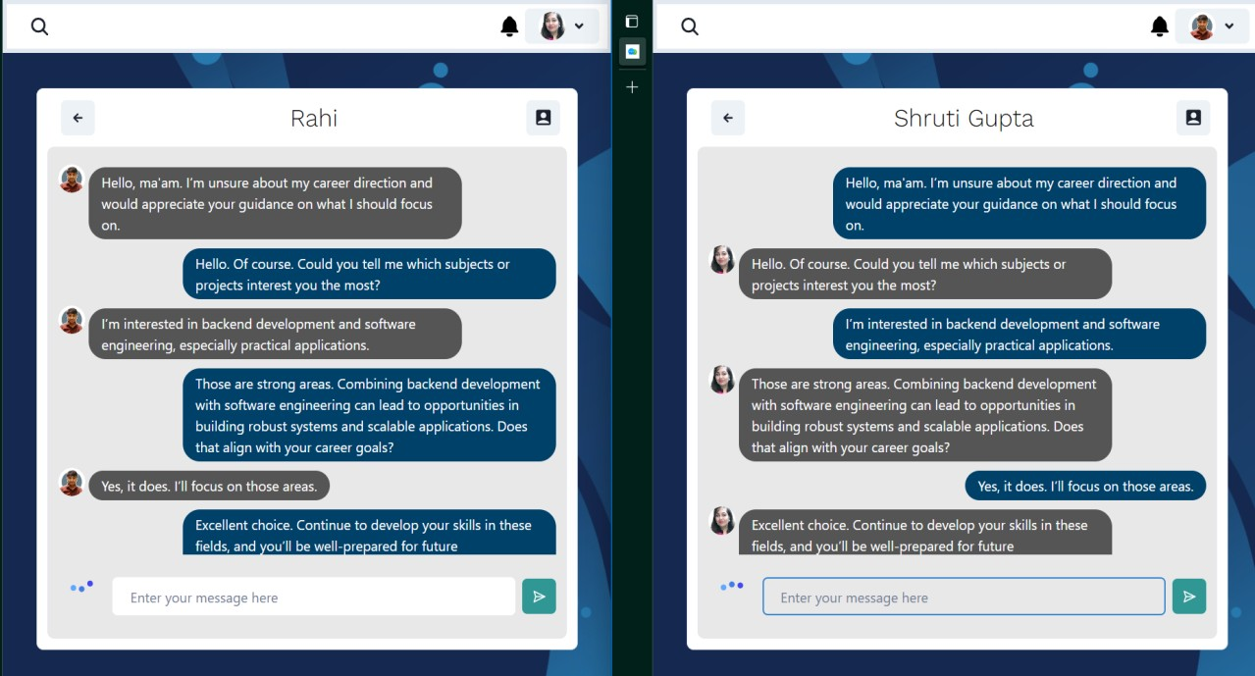

**Figure 3.15 Mentor Chat Room**

**Figure 3.16** shows the database schema designed to manage user profiles and chat logs securely.

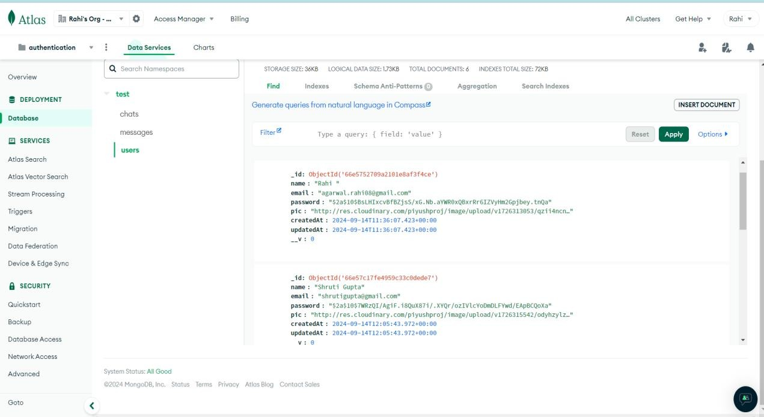

**Figure 3.16 Database for User and Chats**

**Figure 3.17** shows the process flow of the mentorship module, illustrating the interaction between the user, mentor, and system components.

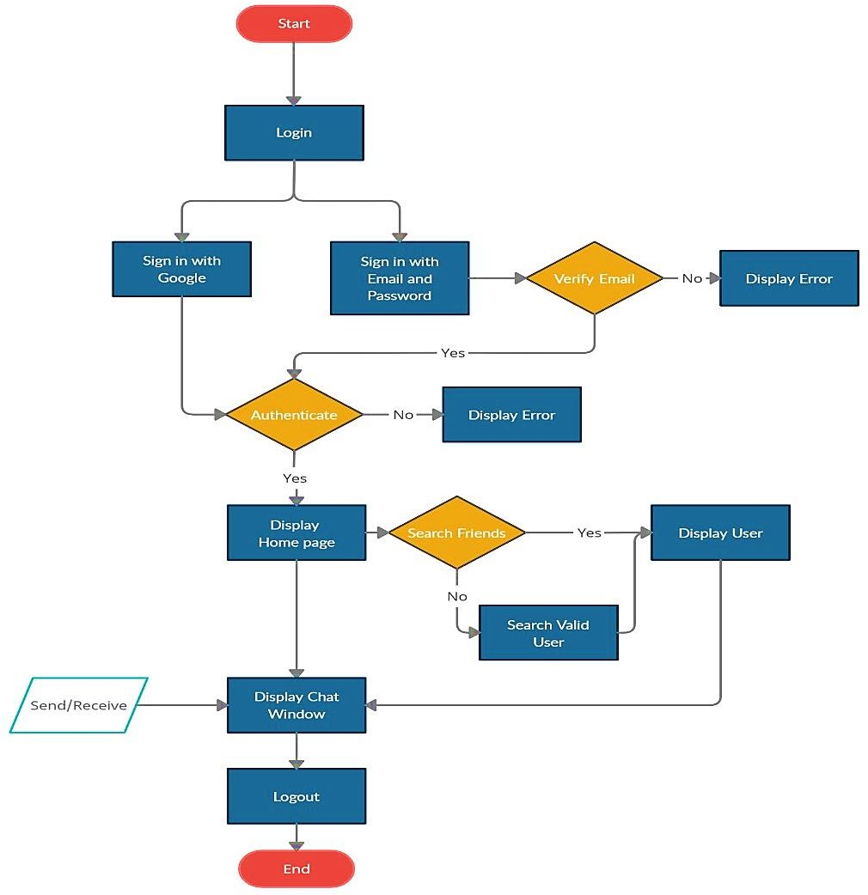

**Figure 3.17 Flow Diagram for MentorShip**

1. **AI-Powered Chatbot**

This feature serves as a virtual assistant for answering queries, conducting mock interviews, and providing instant feedback using natural language processing capabilities. **Figure 3.18** shows the AI interface in python page, which provides an overview of the Interview Question. **Figure 3.19** shows the "About Us" page, which provides an overview of the platform’s mission and features.

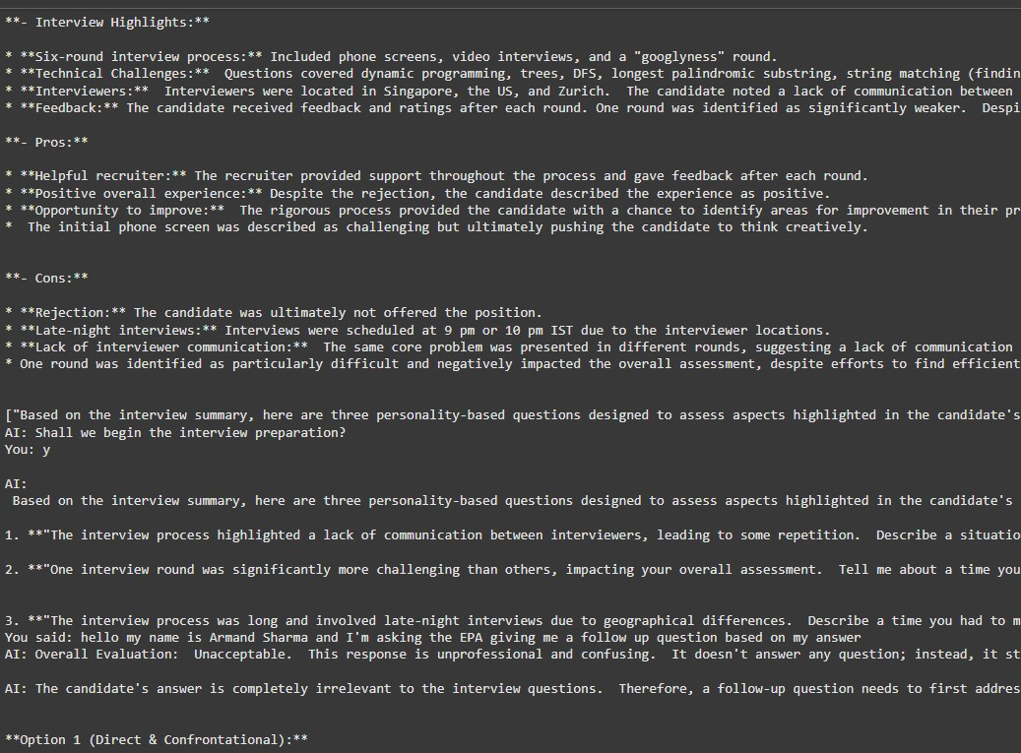

**Figure 3.18 AI Interface in Python**

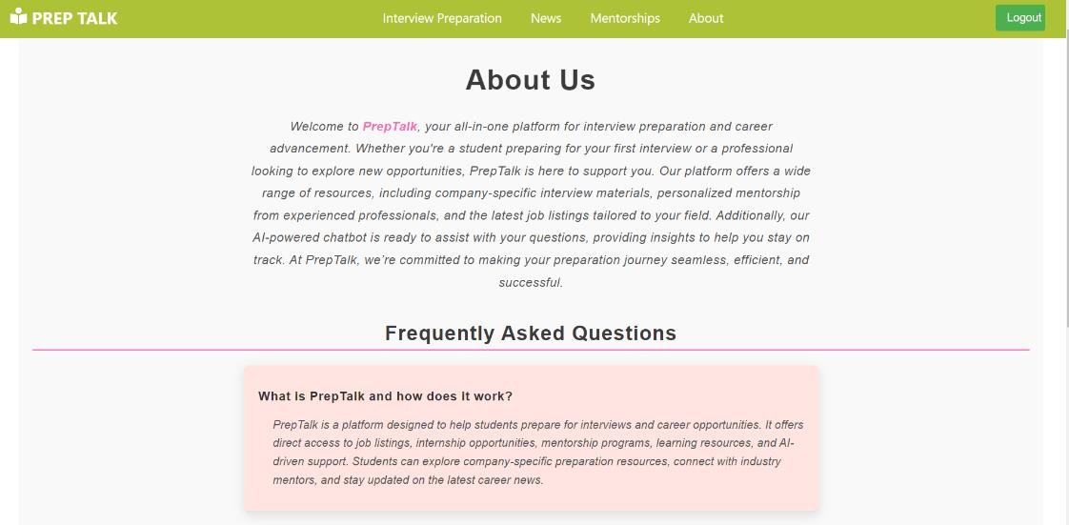

**Figure 3.19 About Us Page**

## Non-Functional Requirements

* 1. **Scalability:**

The solution is designed to handle increasing numbers of users without compromising performance. This involves scalable architecture components like cloud-based servers, efficient database indexing, and optimized code for data handling.

## Security and Privacy:

Given the sensitive nature of user data and mentor communications, robust security measures are essential. This includes encryption, secure authentication, and compliance with data protection regulations.

## Performance:

The application should deliver low latency responses, real-time chat capabilities, and fast page load times to ensure a smooth user experience.

## Usability:

The UI/UX design emphasizes intuitive navigation, responsive design for mobile devices, and user-friendly interfaces for accessing key features.

## 3.2 Solution Approach Overview

The solution combines modular components, each fulfilling a distinct aspect of the overall functionality, while working together to create a seamless user experience. The modules and their integration are as follows:

**3.2.1** **Interview Experience Module Implementation**

User-submitted interview experiences are collected, categorized, and presented through a search-friendly interface. Data sanitization and categorization ensure content relevance, while user contributions enrich the module’s database, creating a dynamic and evolving repository of experiences.

## 3.2.2 News & Job Market Insights

APIs like Google News fetch real-time market updates and job postings, which are curated and displayed based on user preferences. This keeps users informed of market trends, upcoming opportunities, and other relevant information that.

## 3.2.3 Mentor Chatroom Functionality

Real-time mentor interactions are facilitated through a chatroom interface built using web socket technology. Secure authentication and access control mechanisms ensure that only verified users can participate. Mentors offer guidance tailored to user queries, providing unique insights that complement AI-driven

**3.2.4** **AI Chatbot Integration**

The chatbot leverages NLP models to understand user inputs, offer guidance, and simulate mock interview scenarios. Training data consists of categorized interview questions and scenarios, ensuring accurate and useful responses. Real-time interactions enhance the user’s confidence and preparation.

**Chapter 4: Modeling and Implementation Details**

* 1. **Implementation Details and Issues**

## System Architecture Overview

The web application employs a modular architecture, with a focus on scalability and flexibility. It consists of three main layers:

* + - 1. **Frontend Layer:** Developed using React.js, this layer ensures a seamless user interface experience, including features like navigation, mentor chatroom access, and AI chatbot interaction. The UI/UX design emphasizes ease of use and intuitive navigation for users preparing for interviews.
      2. **Backend Layer**: Built using Node.js and Express.js, the backend is responsible for handling user requests, managing data interactions, and integrating external APIs (e.g., Google News API for news aggregation). The backend manages business logic, user authentication, and communication with the database and NLP models.
      3. **Database Layer**: MongoDB serves as the primary database, storing user data, mentor logs, interview experiences, and news data. It provides a scalable solution for handling structured and semi-structured data, enabling fast read/write operations for real-time user interactions.
      4. **AI/NLP Models:** Developed using Python libraries such as TensorFlow and PyTorch for text analysis, sentiment processing, and interaction.

## Detailed Module Implementation

**4.2.1 Interview Experience Module**

This module aggregates user-contributed interview data, categorizes it based on companies and roles, and offers insights through a structured interface. Data is stored in a searchable format, allowing users to easily find relevant content based on their target industry or job role.

* 1. **Data Processing:** Data sanitization and categorization techniques ensure that content is accurate and meaningful.
  2. **Search Functionality:** Users can search for interview experiences by job role, industry, and specific companies, offering targeted content to enhance preparation.

## News & Job Market Insights Module

Utilizing APIs such as Google News, this module aggregates trending news, market insights, and job openings. The data is curated and filtered to deliver personalized content based on user preferences and career goals.

* + - 1. **Data Curation and Display:** Relevant data is organized and displayed on the UI, providing users with insights that enhance their understanding of industry trends.

## Mentor Chatroom

Real-time interactions with mentors occur through the chatroom module, which utilizes web socket-based communication for fast, bi-directional data transfer.

* + 1. **User Authentication and Access Control**: Access to mentors is managed through user authentication, ensuring that only verified users can communicate with mentors.
    2. **Real-Time Messaging:** This feature allows for direct, immediate communication between users and mentors, fostering an interactive experience that is both responsive and effective for personalized guidance.

## AI Chatbot

This component uses natural language processing models to provide automated responses to user queries and conduct mock interview simulations.

1. **NLP Techniques Used:** The chatbot employs sentiment analysis, named entity recognition,and other NLP capabilities to understand and respond appropriately to user inputs.
2. **Interactive Features:** Users can ask questions, seek guidance, or undergo mock interviews. Feedback is provided based on user responses, helping improve their performance and confidence.

## AI and NLP Model Integration

The core of the AI-driven solution is built on NLP models trained to understand user needs, summarize interview experiences, and provide intelligent feedback. Training data includes categorized interview questions, user profiles, and industry- specific content. NLP models are trained and fine-tuned using Python frameworks such as TensorFlow and PyTorch, ensuring accurate responses and meaningful interactions.

## Challenges and Resolutions

Several challenges were encountered during implementation, including data inconsistencies, real-time processing demands, and user privacy considerations. Solutions involved optimizing data handling processes, implementing security protocols to protect user data, and continuously refining AI models to improve accuracy and user satisfaction.

# References

[1] IAFOR Publications, "Artificial Intelligence for Career Guidance – Current Requirements and Prospects for the Future," 2021. Available:

[2] ERIC, "Natural Language Processing for Interview Preparation," 2021. Available:• A. Wagner, J. Strodthoff, T. Vollmer, R. Schaeffter, and W. Samek, "PTB-XL, a large publicly available electrocardiography dataset," PhysioNet. [[https://physionet.org/content/ptb-](https://physionet.org/content/ptb-xl/1.0.3/) [xl/1.0.3/](https://physionet.org/content/ptb-xl/1.0.3/)]

[3] M. Szymanski, P. Langowski, and J. Pietka, "Author(s). *AI Chatbots in Career Development: Enhancing Interview Preparation*," Sensors, vol. 22, no. 3, pp. 1-15, 2023. [[https://www.mdpi.com/1424-](https://www.mdpi.com/1424-8220/22/3/904) [8220/22/3/904](https://www.mdpi.com/1424-8220/22/3/904)]

[4] P. Vollmer et al., "Author(s). *Mentorship Platforms: Integrating AI and Human Interaction for Career Success*, 2023” .[[https://www.nature.com/articles/s41597-](https://www.nature.com/articles/s41597-023-02153-8?fromPaywallRec=false) [023-02153-8?fromPaywallRec=false](https://www.nature.com/articles/s41597-023-02153-8?fromPaywallRec=false)]

[5] Lee, C., & Wang, D. Natural Language Processing for Career Development [[https://link.springer.com/article/10.1007/s11042-022-13428-4]](https://link.springer.com/article/10.1007/s11042-022-13428-4)

[6]Smith, J., & Brown, K. Personalized Career Counseling through AI [[https://www.researchgate.net/publication/354171816_Artificial_Intelligence_for_Career_Gu](https://www.researchgate.net/publication/354171816_Artificial_Intelligence_for_Career_Guidance_-_Current_Requirements_and_Prospects_for_the_Future) [idance_-_Current_Requirements_and_Prospects_for_the_Future]](https://www.researchgate.net/publication/354171816_Artificial_Intelligence_for_Career_Guidance_-_Current_Requirements_and_Prospects_for_the_Future)